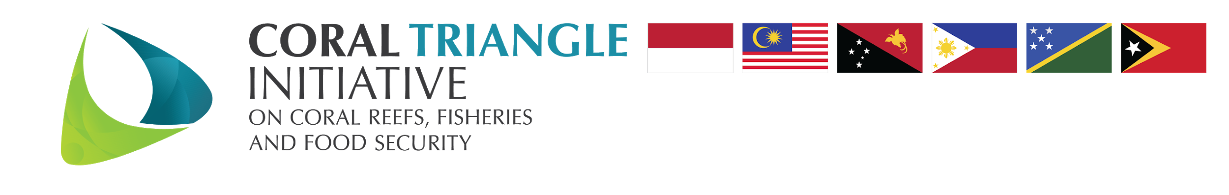

PROPOSED NEW TIMELINE FOR SLEECTION OF NEW ED AND DED-CS
DATE | ACTIVITY
13 June 2023 | 1st Meeting of the Appointment Committee
31 July 2023 | Deadline of submission of application to RS
2 August 2023 | Submission of application to Appointment Committee
16 August 2023 | RS receives shortlisted candidates from AC
24 August 2023 | 2nd Meeting of the Appointment Committee  Proposed agenda:  - Identification of top 5 candidates for ED and top 5 candidates for DED-CS interview based on the shortlist  - Final dates for interview  - Interview mechanics
27 August 2023 | RS to notify the top 5 candidates for ED and top 5 candidates for DED-CS for interview
11 September 2023 | Interview  - Interview of the top 5 candidates for ED and top 5 candidates for DED-CS  - Appointment Committee to discuss the result of the interview and identify recommended ED and DED-CS
15 September 2023 | RS to communicate the result of the interview process to CSO
22 September 2203 | Official letter from CSO to be sent to selected candidate for new ED and DED-CS
October 2023 | RS to arrange work permit for ED from PG and DED-CS (if comes from other Countries outside the Host Country) and other relevant work documentation

